DevOps Project – Industry-Level Roadmap
DevOps Life-cycle Implementation for a Node.js Web Application.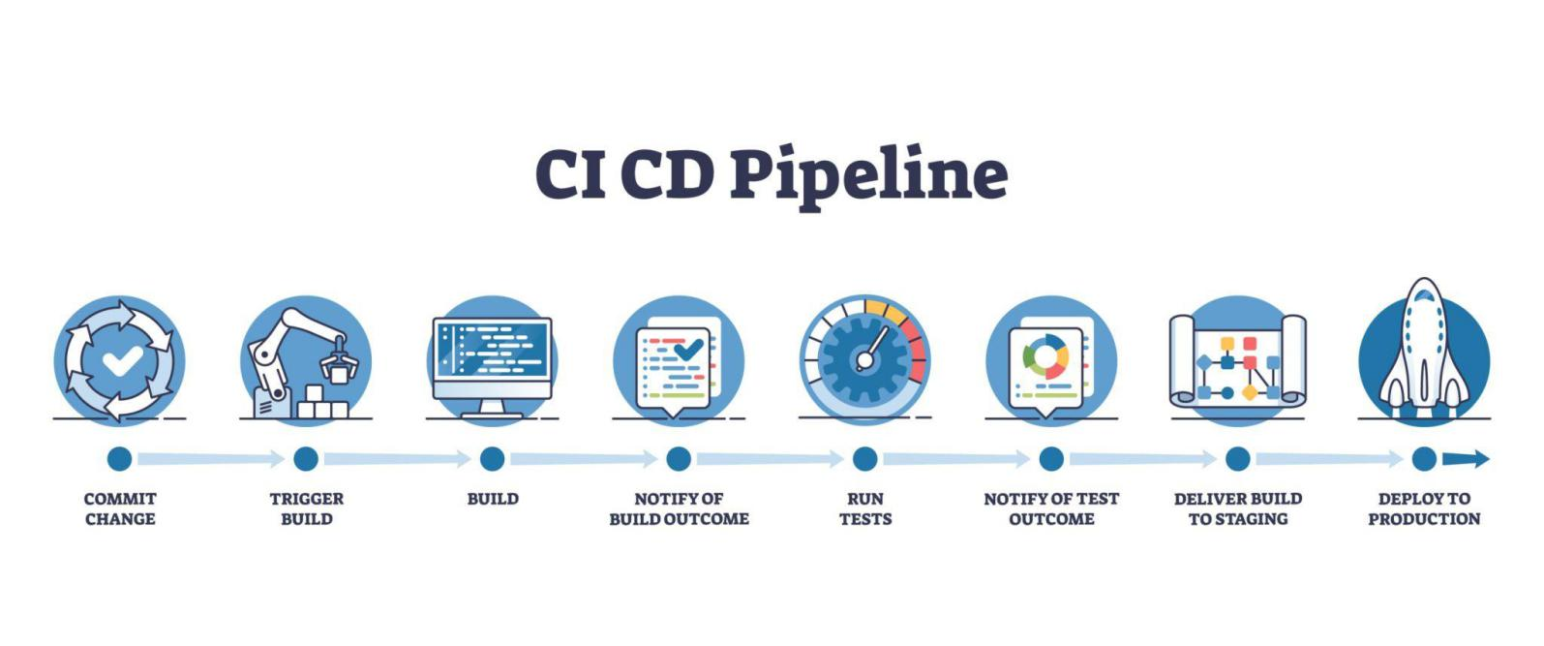
This below diagram illustrates the CI/CD Pipeline architecture for deploying a Web App on Microsoft Azure.
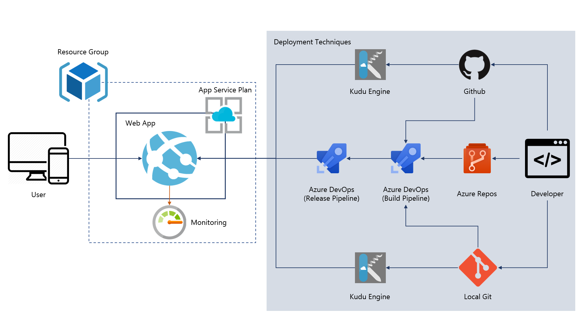

The below image displays a work-flow diagram for a Continuous Integration and Continuous Deployment (CI/CD) pipeline, illustrating how software changes are managed from development to deployment.

- Code Commit: Developer code is committed to a repository, represented by the GitHub Octocat.
- Automation Server: Jenkins automates the process by building the project and creating a Dockerfile.
- Containerization: A Docker image is built based on the Dockerfile.
- Deployment: The final Docker image is pushed to a registry like Docker Hub for distribution.
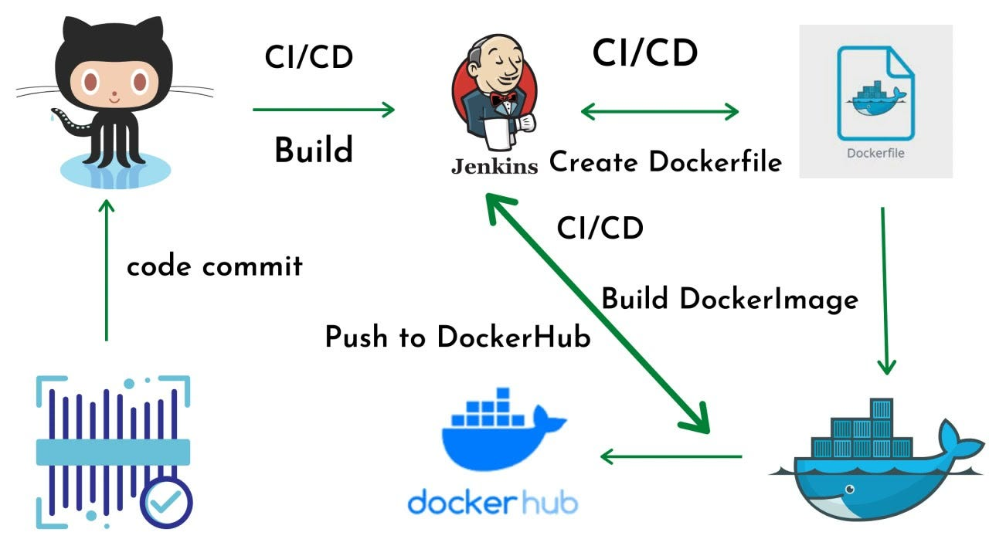
This image illustrates a DevOps Project work-flow showcasing a Continuous Integration/Continuous Delivery (CI/CD) pipeline.
- Version Control & Trigger: Developers check in code to Git, triggering automated build processes.
- Automation Server: Jenkins acts as the orchestrator for the pipeline, handling continuous integration and preparing for continuous delivery.
- Containerization: Docker is used to build container images, which are pushed to a registry and subsequently pulled for deployment.
- Configuration Management & Orchestration: Ansible automates configuration and deployment, while Kubernetes manages the containerized applications in production.
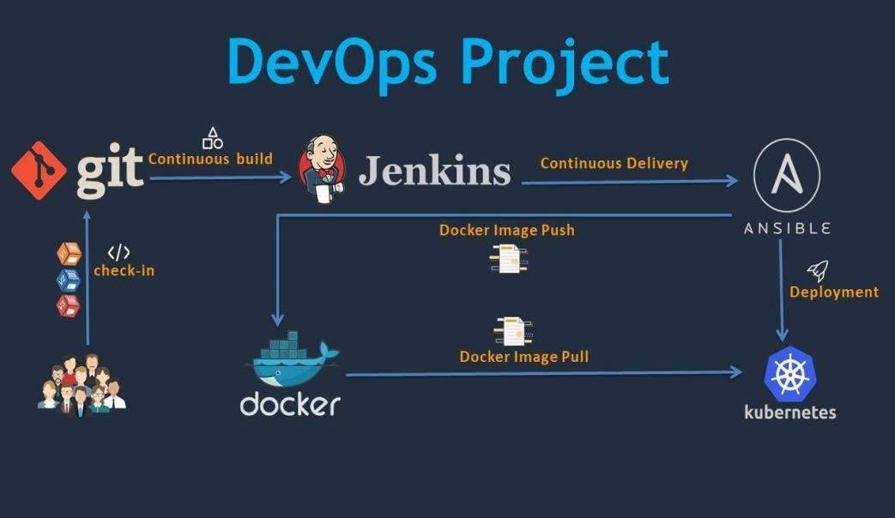
(or)
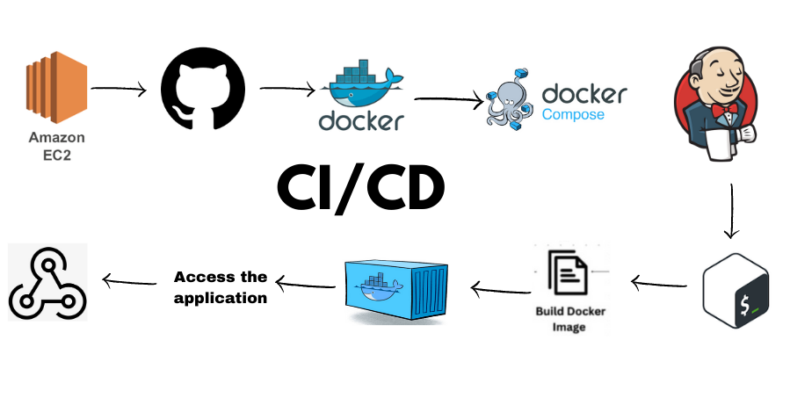

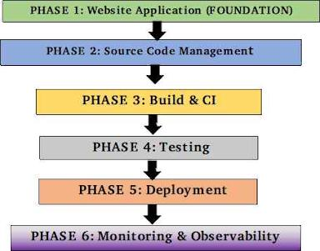

Improve website UI (DevOps theme)
· Create Dockerfile
· Jenkins pipeline (CI)
· Selenium test
· EC2 deployment
· Domain mapping
· Grafana dashboard
· Resume + GitHub polish
1 How a Professional DevOps Project UI Should FEEL :
Think of your website as:
“A living DevOps system, not a blog”
When someone (recruiter / senior engineer / friend) opens your site, they should immediately feel:
✔ This person understands DevOps life-cycle
✔ This project is real, running, monitored
✔ This is not a tutorial copy-paste
Visual Personality :

- Dark theme (tech + ops feel)

- Minimal colors (blue / green)

- Dashboard-style layout

- Clear sections (no clutter)

The Following is the Example Diagram of the Grafana Dashboard :

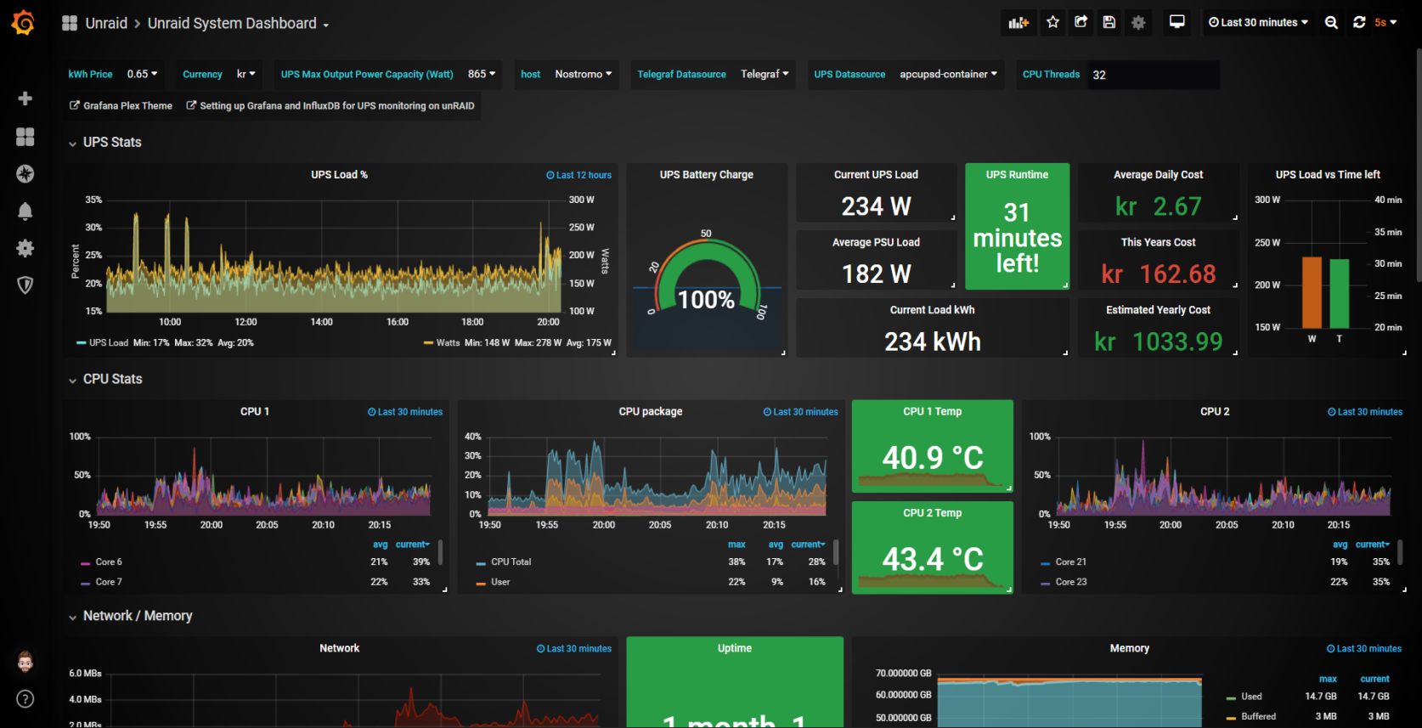

Pipelines list
The Pipelines list shows all the pipelines that you have permission to view. Access CloudBees CD/RO Pipeline list by navigating to Release Orchestration Pipeline Runs.

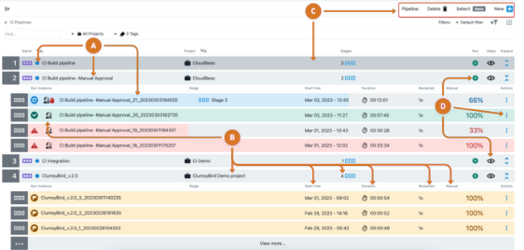
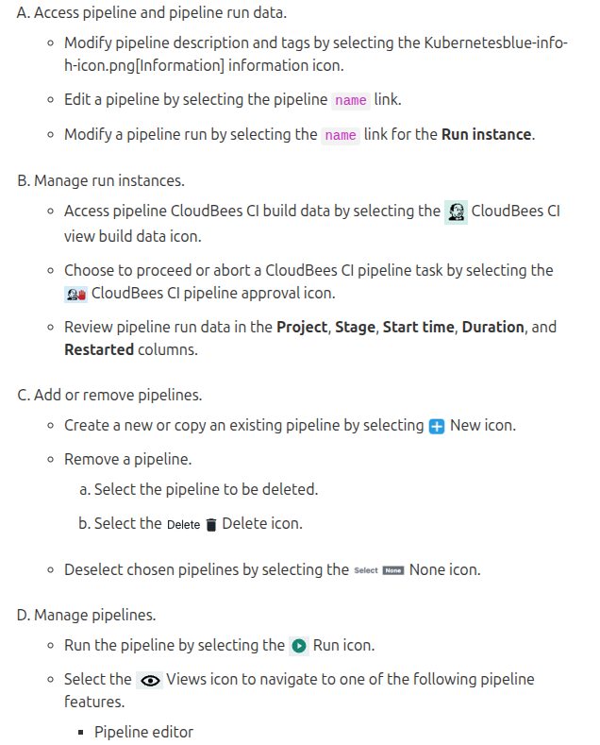
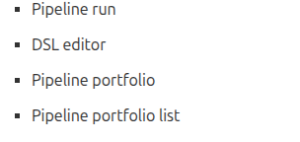
The following is the Link for the Pipeline UI work-flow : https://docs.cloudbees.com/docs/cloudbees-cd/latest/pipelines/pipeline-ui

WEBSITE STRUCTURE (This is the CORE ANSWER)

Top Navigation (Always Visible)
Home | DevOps Work-flow | CI/CD Pipeline | Live Dashboard | Project Info | Contact
PAGE-BY-PAGE PROFESSIONAL DESIGN :
- HOME PAGE ( First Impression)
What NOT to Do:
- Long Devops Theory
- Tool Definitions
- Blog-style content

What Home Page SHOULD SHOW
- Answer this question instantly:
“Is this system live and automated?”

Home Page Layout
Section 1: Hero Section (Top)

Purpose: Confidence
Content:
DevOps Life-cycle Implementation
Automated CI/CD • Cloud Deployment • Live Monitoring
[ View Live Dashboard ]
[ View Pipeline ]
✔ Big title
✔ 2 buttons
✔ No scrolling needed yet
Section 2: Live System Status (IMPORTANT

Cards Like:
Application Status: RUNNING
Last Deployment: SUCCESS
Uptime: 99.9%
Server: AWS EC2
“⚠ Even if values are mock initially, structure must exist.”

Section 3: Architecture Overview

A simple Visual of Flow
“GitHub → Jenkins → Docker → EC2 → Monitoring”
Clickable cards → leads to details page.

Verdict :
Home Page = System health + Confidence -------> NOT documentation
- DEVOPS WORKFLOW PAGE ( Your Brain Display)
This Page answers:
“Does this person actually understand DevOps ?”
Layout
Each card:
- Tool used
- What happens
- Why it matters
# Short. Clean. No essays.

Step-wise Cards:
- Plan – GitHub Issues
- Code – Node.js App
- Build – Docker Image
- Test – Selenium
- Deploy – AWS EC2
- Monitor – Grafana
- CI/CD PIPELINE PAGE(Technical Proof)

This page is for engineers, not HR.
Show:
- Jenkins pipeline stages
- Build logs (last run)
- Docker image version
- Git commit hash
Example layout:
[ Checkout ] → [ Build ] → [ Test ] → [ Deploy ]
✔ Even screenshots are fine initially
✔ Later connect real Jenkins API
- LIVE DASHBOARD PAGE( THE KILLER FEATURE )
This is where you separate yourself.
? Should live dashboard be on Home Page?
Answer:
FULL dashboard ---- NO
Status Summary ---- YES
But the Full Grafana dashboard Separate Page

Live Dashboard Page Shows:
- CPU usage
- Memory usage
- App health
- Request count
- Container status
Embed Grafana panel (iframe).
This Proves :
- System is running
- You know observability
- You didn’t fake project
- PROJECT INFO / ABOUT PAGE
This is NOT “ About DevOps “
This is :
“About THIS SYSTEM”
Content :
- Why this Project
- Problems solved
- Tools & Versions
- Architecture diagram
- GitHub Link
- CONTACT/FOOTER( Professional Touch )
Content :
- GitHub
- LinkedIn
- Resume Link
- Email
Simple , Clean.

Below is an exact, production-style directory tree for your complete DevOps-themed website, designed so that:
- UI is clean & modular
- Each section has a clear responsibility
- It smoothly transitions from Node.js → Docker → CI/CD → AWS → Monitoring
- You do NOT mix logic, UI, and dashboards

devops-website/
│
├── app.js # Node.js entry point (Express server)
├── package.json # Node dependencies & scripts
├── package-lock.json
├── .env # Environment variables (later)
├── .ignore
│
├── Dockerfile # Build phase starts here
├── Jenkinsfile # CI/CD pipeline definition
│
├── public/ # FRONTEND (UI only)
│ │
│ ├── index.html # HOME PAGE (system status + overview)
│ │
│ ├── pages/ # SEPARATE PAGES (clean routing)
│ │ ├── dashboard.html # Live monitoring page (Grafana embed)
│ │ ├── workflow.html # DevOps life-cycle explanation
│ │ ├── cicd.html # CI/CD pipeline visualization
│ │ ├── about.html # About THIS project (not DevOps theory)
│ │ └── contact.html # Contact / links
│ │
│ ├── components/ # REUSABLE UI BLOCKS (VERY IMPORTANT)
│ │ ├── navbar.html # Top navigation
│ │ ├── footer.html # Footer
│ │ ├── status-cards.html # System status cards (used in Home)
│ │ ├── workflow-cards.html# DevOps phase cards
│ │ ├── pipeline-cards.html# CI/CD stages UI
│ │ └── metric-cards.html # CPU, Memory, Uptime cards
│ │
│ ├── css/
│ │ ├── main.css # Global styles (dark theme)
│ │ ├── layout.css # Grid, sections, spacing
│ │ ├── cards.css # Cards (status, metrics, pipeline)
│ │ ├── dashboard.css # Dashboard-specific UI
│ │ └── responsive.css # Mobile/tablet support
│ │
│ ├── js/
│ │ ├── main.js # Global JS (navbar load, utilities)
│ │ ├── status.js # App status (mock → real API later)
│ │ ├── dashboard.js # Dashboard logic (iframe, refresh)
│ │ ├── cicd.js # Pipeline status handling
│ │ └── utils.js # Reusable helpers
│ │
│ ├── assets/
│ │ ├── images/
│ │ │ ├── logo.svg
│ │ │ ├── architecture.png
│ │ │ └── pipeline.png
│ │ │
│ │ └── icons/
│ │ ├── github.svg
│ │ ├── docker.svg
│ │ ├── aws.svg
│ │ └── jenkins.svg
│ │
dashboards/
│ └── # Monitoring embeds
│ └── grafana.html # Isolated Grafana iframe page
│
├── routes/ # Backend routes (later expansion)
│ ├── health.js # /health endpoint (for monitoring)
│ └── status.js # App status API
│
├── tests/ # TEST PHASE
│ └── selenium/
│ ├── homepage.test.js
│ ├── dashboard.test.js
│ └── workflow.test.js
│
├── monitoring/ # OBSERVABILITY
│ ├── prometheus.yml
│ └── node-exporter.md
│
└── README.md # Project explanation (for GitHub)

How this tree helps DevOps life-cycle
Phase | What part
Source | GitHub repo
Build | Dockerfile
CI | Jenkinsfile
Test | Selenium tests
Deploy | EC2 container
Monitor | Grafana / Prometheus
UI | public/

Everything has one clear responsibility.

